Go to Mahadbt Website : https://mahadbtmahait.gov.in/

Click on Post matric scholarship

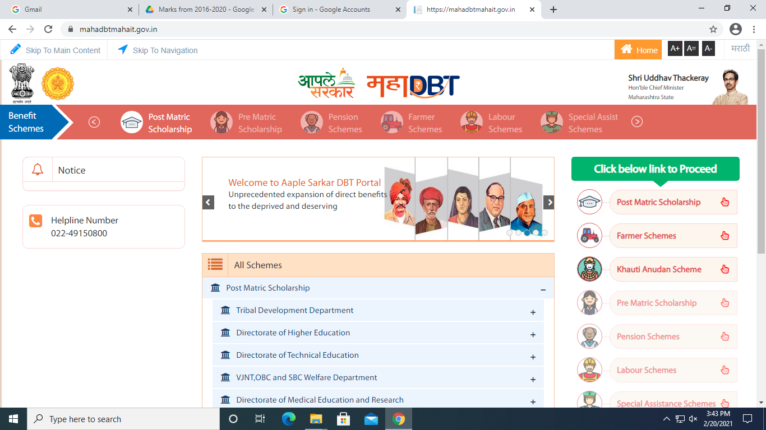

Click on New Applicant Registration Students who is having old username & password login with the same on Applicant login.

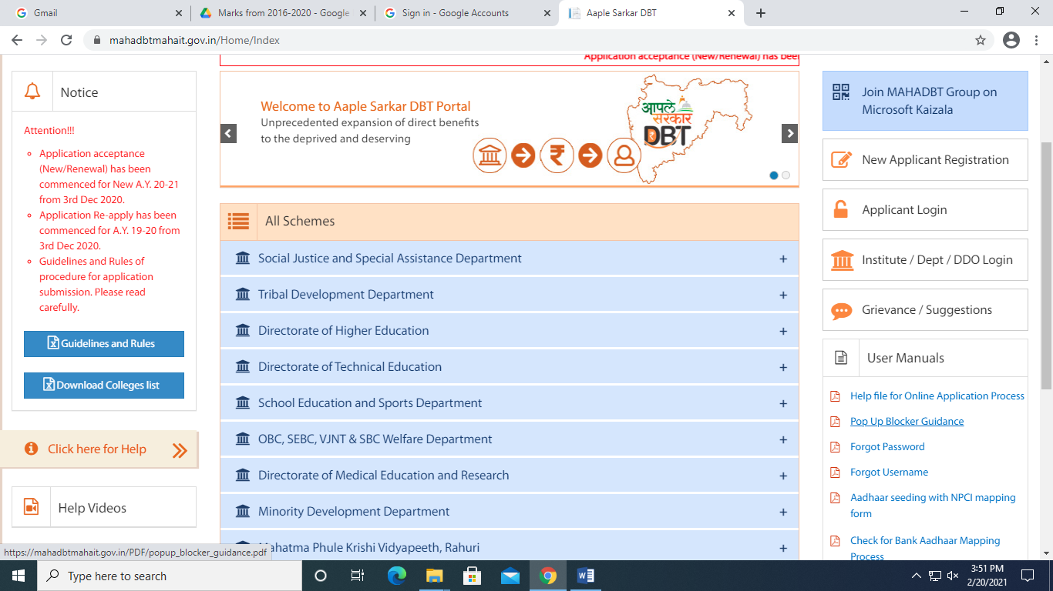

Do new registration

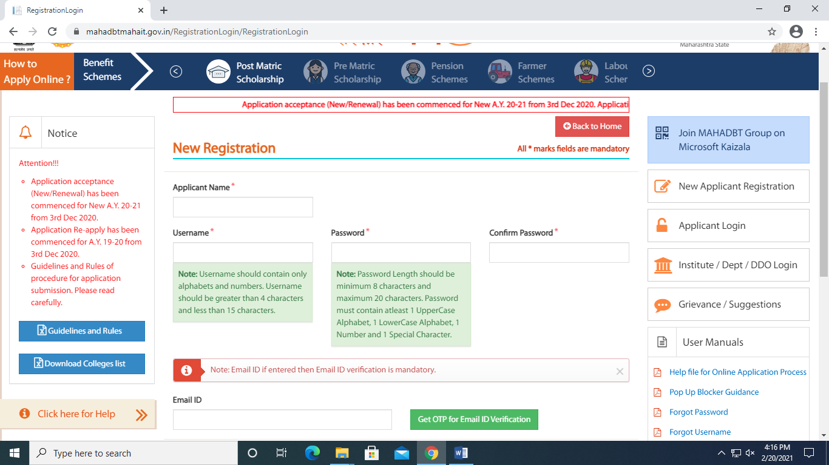

Once you get username and password click on applicant login and fill data.

* Crieteria for Scholarship
* Students who admitted through Cap Round is eligible to apply for all types of Government scholarship & freeship schemes.
* **Only Minoriy students (Muslim, Christian Parsi, Buddhist, Parsi (Zorastrain) & Jew can apply for minority scholarship even though they admitted through Institute level or Against Cap. (Direct Admission)**
* Student should be domiciled of Maharashtra State & having domicile certificate.
* Income should be below Rs.8,00,000/-
* All schemes are based on Aadhar Card linking. So make sure your Aadhar number is linked with proper phone number and bank account. Verify your mobile number is linked with Aadhar, is same in bank and your application form also. Pls check your Aadhar mapping is done by your bank on NPCI portal. For this process meet me. (Snehal Dhumak)
* Students who is having their old username & password of mahadbt login with old username only. Make sure don’t make another username.
* Open/EWS category students who admitted through cap round is eligible for (EBC) Even minority student can also apply for this scheme if admitted through cap round only.

They can apply on mahadbt portal for (Scheme - Chhatrapati Rajarshi Shahu Maharaj Shishyavrutti yojana / Department- Directorate of Technical Education)

* OBC category students who admitted through cap round is eligible for (Freeship.) They can apply on mahadbt portal for (Scheme Tution fees and Examination fees to OBC / Department- OBC, SEBC, VJNT & SBC Welfare Department
* SBC category students who admitted through cap round is eligible for (Freeship) They can apply on mahadbt portal for (Scheme Tution fees and Examination fees to SBC / Department- OBC, SEBC, VJNT & SBC Welfare Department
* NT category students who admitted through cap round is eligible for (Freeship) They can apply on mahadbt portal for (Scheme Tution fees and Examination fees to NT / Department- OBC, SEBC, VJNT & SBC Welfare Department
* SC category students who admitted through cap round & income is more than 2.5 lakhs is eligible for (Freeship) They can apply on mahadbt portal for (Scheme Post Matric Tution fees (freeship) / Department- Social Justice and Special Assistance Deaprtment )
* SC category students who admitted through Cap & Against Cap round & income is less than 2.5 lakhs is eligible for (Scholarship) They can apply on mahadbt portal for (Scheme – Government of India Post Matric Scholarship) / Department- Social Justice and Special Assistance Deaprtment )
* Minority students can apply on mahadbt for (Scheme –Scholarship for students of minority communities pursuing Higher and Professional course (DTE) / Department- Directorate of Technical Education)
* If any query regarding this pls contact **Mrs. Snehal Dhumak on 02262764583 between 10.30 a.m to 5.30 p.m.**
* **Only SC & ST students can apply for scholarship scheme.**

**EBC/EWS/ OBC/SC/ST/NT/SBC girls put 0 in paid fees tab.**

**EBC/EWS/ OBC boys put 50% tution fees in paid fees tab. Check tution fees on fee receipt.**

**SBC/ST/NT/SC boys put 0 in paid fees tab.**

**Documents List for (EBC/Minority Student) with proper zerox. No scan copy will be accepted.**

1. Income cert of 24-25 (]%pnaacaa daKlaa) by Tahsildar
2. Certificate of Domicile
3. 10th marksheet
4. 12th marksheet
5. Leaving
6. Gap applicable
7. Graduation Marksheet of all sem
8. Acknowledgement Receipt (Given by Megha Madam at the time of admission)
9. Bank passbook copy

10. Ration card

11. Aadhar Card

12. Declartion

13. Fees certificate (you will get this through ERP login)

14. Caste Certificate (If applicable)

15. Caste validity (If applicable)

16. Noon creamy layer (If applicable)

17. EWS certificate (If applicable)

* **Submit hard copy of mahadbt form with zerox copy (No scan documents print) to institute till 10th October 2025**